I am better than your kids.
If you work in an office with lots of people, chances are that you work with a person who hangs pictures up that their kids have drawn. The pictures are always of some stupid flower or a tree with wheels. These pictures suck; I could draw pictures much better. In fact, I can spell, do math and run faster than your kids. So being that my skills are obviously superior to those of children, I've taken the liberty to judge art work done by other kids on the internet. I'll be assigning a grade A through F for each piece:
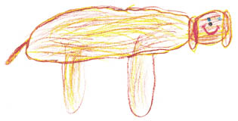  Megan, age 4 | First of all, I don't even know what this is. If it's supposed to be a dog, then it's the shittiest dog I've ever seen. F
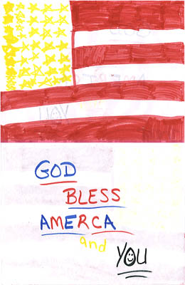  Kyle, age 8 | You spelled America wrong asshole. Also, I could have sworn America's colors were red, white and blue. There's no yellow anywhere, traitor.F
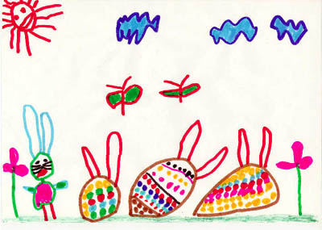  Alex Sweetingham, age 22 | Holy shit, I almost had a seizure when I saw this one. Three words: too many colors. Also, eggs aren't supposed to have ears, dipshit.F
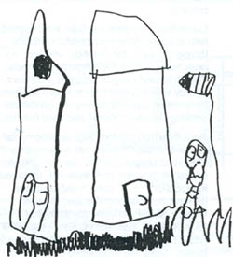  Cameron, age 4 | Terrible. F
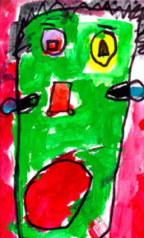  Bryce, age 10 | This one wouldn't be too bad if the color was kept inside the lines, you picked a new perspective, used non-abrasive colors and asked someone with talent to paint it for you On one hand I want to give an A for effort but... F
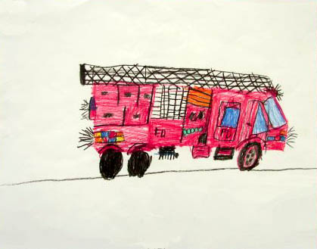  Jon, age 8 |  | Ding Ding! Here comes the shit-mobile. I've never seen a fire truck that needed to be shaved. I would rather be burned to death than be saved by this hairy piece of shit. F
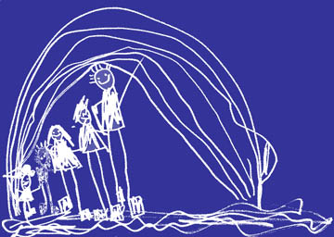  Rachel, age 7 |  | That's interesting, everyone in this picture is white. Even the rainbow is white. Perhaps in an ideal world, everyone would be white isn't that right, Rachel? Or should I call you RACIST? Nice try, Hitler. F
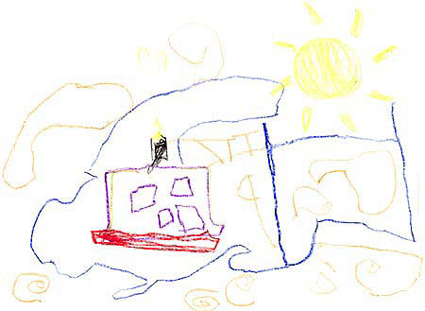  Jason, age 6 |  | This one would receive an "A" if the assignment was to throw as much random shit onto a paper as poorly as you can. I've pissed patterns on snow that look more coherent than this. F
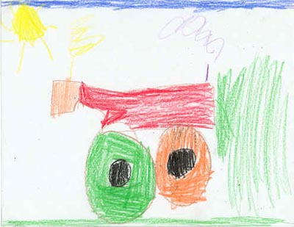  Seth, age 4 |  | Vrrrroooooooooooommmmmm! Grade: F
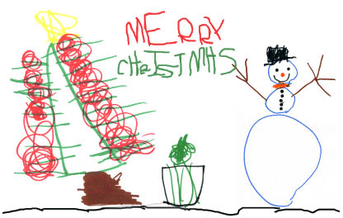  Kelly, age 9 |  | This was a Christmas gift from Kelly to her parents. Good job Kelly, now pack up your shit and find a foster home. If my kids tried to pass this off as a gift, they'd come home from school and find all their shit outside in a box. What a lousy gift, seriously. You give them video games and toys, and they give you some half-assed drawing with a crooked tree. I wonder how much a gift like this would set someone back. Five, maybe ten minutes to find a napkin and some markers? F

