Please pass this on to any woman you know who use Tesco’s

A new scam is being pulled on women mainly in broad daylight in Tesco’s car parks.

What happens is that when the intended victim goes back to her car to put her shopping in the boot, an almost NUDE, good looking, tanned, muscled young man comes up to her car and pretends to wash the windscreen….

While he is doing this, another 2 young, handsome athletic men open the back doors of the car, jump in and insist the woman drive off with them to some lonely spot, where 2 have their wicked way with her and the other steals her handbag….

They are very good at this…

They got me three times Friday and five times Saturday.
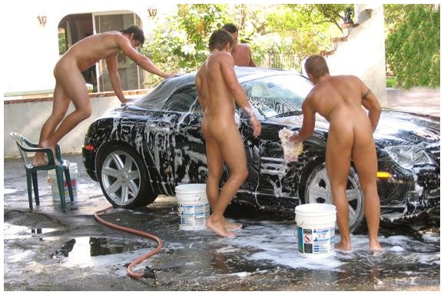

I couldn't bloody find them on Sunday.

