Why bicycle shorts are always black!!

Black:


Scroll down
NOT Red:
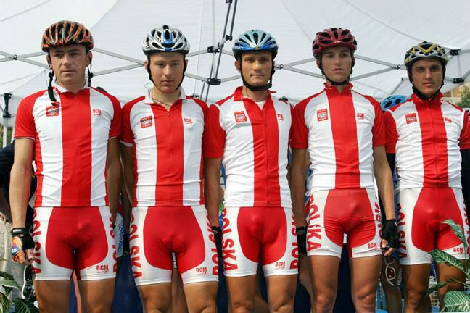
Your smile is your best friend...make it someone elses' too!

