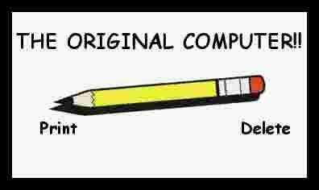

Memory - was something you lost with age

An application - was for employment

A program - was a TV show

A cursor - used profanity

A keyboard - was a piano

A web - was a spider's home

A virus - was the ‘flu

A CD - was a bank account
A hard drive - was a long trip on the road
A mouse pad - was where a mouse lived
And if you had a 3 inch floppy


. . you just hoped nobody ever found out!???

